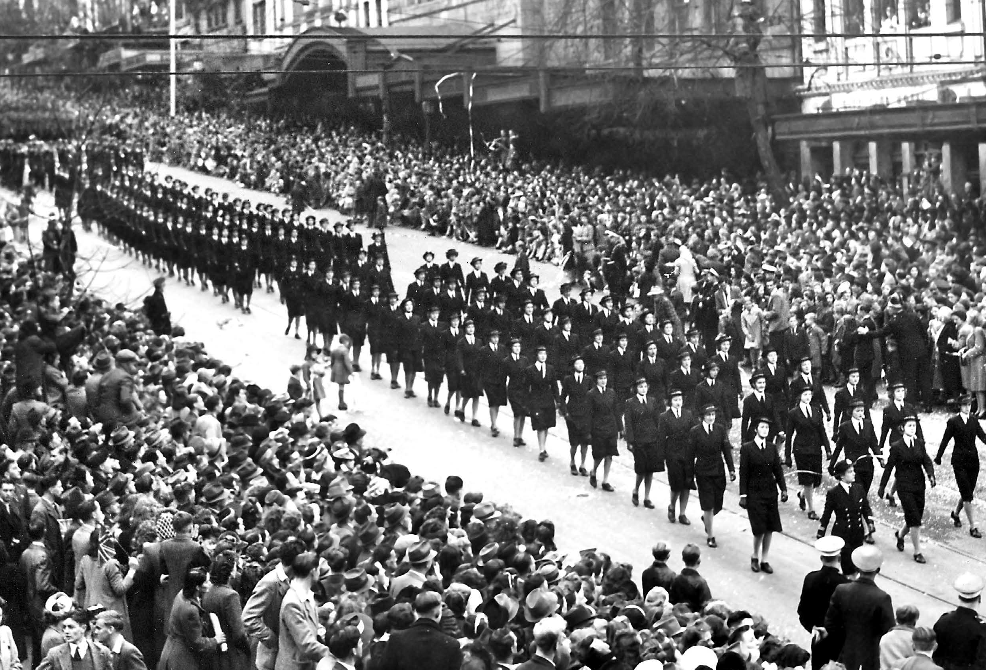

Victorian Veterans Council

Annual Report 2019/20

Cover image supplied by Argus Newspaper Collection of Photographs, State Library of Victoria

Contents

Chairperson’s Foreword **4**

About the Victorian Veterans Council **7**

Objectives and Functions of the Victorian Veterans Council **8**

Members of the Victorian Veterans Council **9**

Highlights of the Year **15**

Corporate Governance **17**

Anzac Day Proceeds Fund **19**

Victorian Veterans Fund **21**

Patriotic Funds **23**

# Chairperson’s Foreword

|  |  |
| --- | --- |
| Photograph of Roger Clifton | **The past year has been a challenging one for Victoria’s veteran community, with social isolation and the impacts of coronavirus (COVID-19) on employment and security being felt broadly.**  **Amazingly though, the spirit of generosity and mateship for which our veteran community is so renowned also came shining brightly through.** |

## COMMEMORATION AND SUPPORT

With that spirit of community and service front of mind, we – fittingly – this year commemorated the bravery and sacrifice of the nearly one million Australians who went off

to World War Two (WWII), as we marked the 75th Anniversary of Victory in Europe Day, and Victory in the Pacific Day; the official end of the war for Australia.

The Victorian Government’s commemorative program to mark this anniversary was a wonderful opportunity to reflect, but also to thank our living WWII veterans, many of whom are now in their late 90s and 100s.

I was pleased to participate in grant assessments for the 75th anniversary, which resulted in a wonderful virtual program of events that provided engagement opportunities for all Victorians – so important at a time when traditional commemorations and services cannot be held.

Also vitally important right now is the continued support of our ex-service community, and I thank the Victorian Government for new funding announced in April 2020, which will be distributed in the next financial year through the ANZAC Day Proceeds Fund and Victorian Veterans Fund grant programs.

I also thank the Veterans Branch, Department of Premier and Cabinet (DPC) for its hard work in continuing to deliver these grant programs, which in 2019-20 provided a total of $961,113 across 67 projects and welfare initiatives.

## THE COUNCIL’S FOCUS

In order to ensure this support reaches those who really need it, the VVC has this year continued to focus on communication and engagement with the ex-service community, including working closely with DPC to update and refresh our database of ex-service organisations in Victoria.

I would like to thank my fellow VVC members for their adaptability in meeting virtually to continue VVC business and ensure we continue to meet our objectives under the *Veterans Act 2005.*

I would also like to thank former Chair Lieutenant Colonel Laureen Grimes, former RSL Victoria representative Brigadier Michael Annett CSC, and former Melbourne Legacy representative Mr Geoff Brewer for their tireless work advocating for our ex-service community.

And I am delighted to welcome new RSL Victoria member Mr Jamie Twidale CSM and Ms Anita Hogan who joined the VVC this year. I also congratulate member Ms Pelagia Markogiannakis on her appointment as Deputy Chair in January 2020.

Lastly, I acknowledge and thank Dr Ross Bastiaan AM RFD and Mr Bruce Mildenhall for their work chairing the VVC’s Funding and Governance Sub-Committees, and thank the VVC members for their contribution to the committees.

## COMMUNITY ENGAGEMENT

Before coronavirus (COVID-19), the VVC was fortunate to have spent some time out and about, including an insightful visit to the Heidelberg Repatriation Hospital in September 2019. This was a wonderful opportunity to learn more

about the work of the Veteran Liaison Officers and the contemporary operations of the Veterans’ Psychiatry Unit, commonly known in the ex-service community as ‘Ward 17’.

I was also pleased to attend the Australian Nurses Memorial Centre and Albert Coates Memorial Trust scholarship awards nights, supported by the VVC as the trustee for patriotic funds on behalf of the Australian Legion of Ex-Servicemen and Women.

## FUTURE FOCUS

The VVC recently welcomed the new Minister for Veterans, the Hon Shaun Leane MP, and the VVC looks forward to working closely with him in 2020-21.

As we look to the future, the VVC has some big projects in the wings focused on broadening our reach in the

ex-service community. This includes a new program of engagement under a new 2021 Communications Strategy.

We are also excited to be working closely with the Minister for Veterans and DPC on a detailed Veterans Sector Study this coming year, which will help give us further insights to better support every Victorian veteran.

I thank you for your interest in the work of the VVC and am pleased to present the VVC’s 2019-20 Annual Report.



**ROGER CLIFTON**

CHAIR

# About the Victorian Veterans Council

The Victorian Veterans Council (VVC) is an independent statutory body established in August 2006 under the *Veterans Act 2005* (the Act).

The VVC plays an important role in supporting Victorian veterans and their families and is responsible for reporting to the Minister for Veterans on issues affecting the Victorian veteran community.

Under the Act, the VVC has specific responsibility for the distribution of the ANZAC Day Proceeds Fund and Victorian Veterans Fund. The VVC also assists the government by providing:

* general advice to the Minister for Veterans on issues affecting Victoria’s veterans such as the current and future needs of veterans and their families
* advice to the Director of Consumer Affairs on matters relating to the regulation of patriotic funds
* advice on a range of government programs and initiatives such as, the Premier’s Spirit of Anzac Prize, the Victorian Anzac Tertiary Multimedia Prize, the Veterans Accommodation Project, and the Shrine to Sea Project.

The VVC is supported by the Veterans Branch within the Department of Premier and Cabinet (DPC).

# Objectives and Functions of the Victorian Veterans Council

The objectives and functions of the VVC are detailed in Sections 5 and 6 of the *Veterans Act 2005* (the Act).

The objectives of the VVC are to:

* promote the wellbeing of all members of the Victorian ex- service community
* promote the commemoration of those who have died in the performance of service or duty
* develop a better understanding amongst Victorians of the service and sacrifice of Victoria’s veterans in war and peacekeeping operations and the contributions of Victoria’s ex-service community
* actively promote the significance of, and key values associated with, the spirit of Anzac
* promote cooperation and collaboration across organisations dealing with veterans welfare and other ex-service community issues, including the Trustees of the Shrine of Remembrance.

The functions of the VVC are to:

* ensure that the objectives of the VVC are met to the maximum extent that is practicable
* monitor and advise the Minister for Veterans on issues affecting Victoria’s ex-service community
* investigate and report on any aspect of veterans affairs referred to it by the Minister
* consult with the ex-service community when developing advice for the Minister
* support the welfare activities of ex-service organisations through the ANZAC Day Proceeds Fund (in accordance with the ANZAC Day Act 1958)
* fund activities furthering its objectives through the Victorian Veterans Fund (in accordance with Section 20 of the Act)
* advise the Director of Consumer Affairs on matters in relation to the regulation of patriotic funds under Part 4 of the Act.

# Members of the Victorian Veterans Council

|  |  |
| --- | --- |
| Photograph of Roger Clifton | ROGER CLIFTON **CHAIR**  **(Appointed 15 October 2019)** |

Roger has an extensive family background in the military with his Father serving in the Navy during World War Two. Both his father’s brothers paid the ultimate sacrifice in World War Two with one being lost on HMAS Sydney when she was sunk off the Western Australian coast, and the other killed in action while serving in the Middle East and Mentioned in Despatches.

Roger served in Vietnam in the early 70s as a conscript. He later had a four-decade career in Advertising and Marketing, as Managing Director of the Melbourne offices of three international advertising agencies, one of which he was a principal. He retired from full time work in 2008. Roger is also a Trustee of The Shrine of Remembrance and a Director of William Angliss Institute of TAFE.

|  |  |
| --- | --- |
| Photograph of Lieutenant Commander Pelagia Markogiannakis | **LIEUTENANT COMMANDER PELAGIA MARKOGIANNAKIS**  **DEPUTY CHAIR**  (Appointed 6 February 2018,  appointed Deputy Chair 29 January 2020) |

Pela has been a Navy Reservist since 1986 and has attained the rank of Lieutenant Commander. She has held a variety of logistics, engineering and infrastructure related roles. Pela is an engineer and certified project professional. She has been the Aide-de-Camp in Waiting to His Excellency the Governor of New South Wales and the His Excellency the Administrator of the Commonwealth of Australia. She is currently serving

in a staff role to Shore Force at Fleet Headquarters, Sydney and is the Staff Officer for Reserves in Victoria reporting to the Head of Reserves in Canberra. Pela currently holds the executive infrastructure governance role with Major Road Projects Victoria.

|  |  |
| --- | --- |
| Photograph of Dr. Ross Bastiaan | DR ROSS BASTIAAN AM RFD (Appointed 1 January 2013) |

Ross enlisted in the Army Reserve in 1975 and was attached to 3 Army Field Ambulance. In the Royal Australian Army Dental Corps (Res) he was promoted to Colonel Consultant and was attached to Defence Health Services Branch, Canberra. Ross served on the Council of the Australian War Memorial from 1995 to 2009. Since 1990 he has personally placed over 290 multi-lingual, large bronze commemorative plaques at various locations around the world from Europe to the Great Ocean Road in Victoria. He has also written three books on WWI and WWII. Since 1978 Ross has worked in private practice as a periodontist.

|  |  |
| --- | --- |
| Photograph of Wing Commander Sharyn Bolitho Raafar | WING COMMANDER SHARYN BOLITHO RAAFAR (Appointed 4 November 2015) |

Sharyn Bolitho joined the Royal Australian Air Force in 1987 and during her time in the RAAF she held postings on the staff of the Chief of Defence Force (working for Admiral Chris Barrie at the time of the terrorist attack on 11 September 2001) and was later responsible for joint operational personnel issues relating to deployment in 2002, receiving a Commendation from Commander Australian Theatre. Sharyn was appointed Commanding Officer of Combat Support Unit East Sale in December 2008, transitioning to Commanding Officer No 30 (City of Sale) Squadron when it was reformed 1 July 2010. She left the Permanent Air Force in May 2012 to remain in Sale and accepted an appointment as Manager Economic Development at Wellington Shire Council. Sharyn transitioned back to RAAFAR in 2017 at RAAF Base East Sale and is now in an Executive Support and Heritage role.

|  |  |
| --- | --- |
| Photograph of Geoffrey Brewer | GEOFFREY BREWER (Member from 26 March 2019 – 3 June 2020) |

Geoff Brewer completed National Service with 2RAR in 1966- 1967, including a tour of duty to Vietnam in 1967 where he served as an infantryman. Following his military service, Geoff returned to his career as a teacher in Victoria. In 1984, Geoff was awarded an International Teaching Fellowship placement at Hoover Middle School in Buffalo, New York. Geoff spent

the final 11 years of his teaching career as Principal of Solway Primary School, before retiring in 2000. Geoff has been a longstanding member of Melbourne Legacy, serving as the convenor of the Melbourne Legacy Education Panel for 16 years, and as the Legacy member of the Veterans’ Children Education Scheme Victorian Board since 2001. Geoff is the Legacy member of the Victorian Veterans Council.

|  |  |
| --- | --- |
| Photograph of Elizabeth Brown | ELIZABETH BROWN (Appointed 30 September 2014) |

Elizabeth is a widow of a Vietnam veteran, was a carer to her father-in-law (a WWll veteran) and has been a Pensions/ Welfare Officer for the past eight years. She has completed a law degree at Victoria University, is a qualified Associate Accountant and has worked in finance roles across government. Elizabeth was nominated for appointment to the Council by the Vietnam Veterans Association of Australia Victorian Branch (Noble Park Sub-Branch).

|  |  |
| --- | --- |
| Photograph of Anita Hogan | ANITA HOGAN (Appointed 24 March 2020) |

Anita is a Royal Australian Navy veteran. She joined the Australian Defence Force at the age of 16 and served from 1994 to 2004. During that time, she trained as a Dental Assistant and worked at several ADF bases. After leaving the Australian Defence Force, Anita retrained and works as a Medication Endorsed Enrolled Nurse, as well as being actively involved in volunteering with RSL Cranbourne-Dandenong Sub-Branch where she has formed strong connections

with the younger veteran cohort and provided welfare and advocacy support to them. Anita has lived experience of many of the issues facing contemporary veterans transitioning to civilian life. She is an active member of Young Veterans, a social group for veterans based in Cranbourne.

|  |  |
| --- | --- |
| Photograph of Lieutenant Commander Peta Irving Ran | LIEUTENANT COMMANDER PETA IRVING RAN (RTD) (Appointed 7 August 2018) |

Lieutenant Commander Peta Irving RAN (Rtd) joined the Women’s Royal Australian Naval Service in 1983 after spending four years in the Army Reserve Artillery Corp. Peta joined as a Naval Supply Officer and was one of the first six females to serve at sea in a permanent position on the HMAS JERVIS BAY in 1985. While in the Navy Peta was logistics officer for Operation RELEX and specialised in IT logistic systems as a Project Manager. Peta has a Master of Business Administration and has graduated from the Australian Institute of Company Directors. Since leaving the Navy, Peta has been teaching and consulting in Project Management and Supply Chain and Logistics, mentoring and volunteering.

|  |  |
| --- | --- |
| Photograph of Kim McAliney | KIM MCALINEY (Appointed 30 August 2016) |

Former Wyndham City Mayor and Councillor, Kim McAliney joined the Veterans Council in 2016. Kim has had a long history of community involvement, both in Local Government and community level and has wide business experience. Raising two sons, with a career spanning over 30 years, Kim has worked at accountancy firms, in the aged care and retirement sector, a multi-national company and a National Crisis Counselling Service and held numerous board directorships. Kim is FCPA qualified, has an Advanced Diploma in Public Safety (Emergency. Mgt), is a Graduate of the Australian Institute of Company Directors (AICD) and currently studying Justice. A Trust member of the Greater Metropolitan Cemeteries Trusts (GMCT) since 2013, Kim is a Director of the Think Pink Foundation since 2019 and is a former Chair of the Salvation Army State Social Command – Victoria and Director City West Water. Kim is a current serving Justice of the Peace and Bail Justice.

|  |  |
| --- | --- |
| Photograph of Bruce Mildenhall | BRUCE MILDENHALL (Appointed 7 August 2018) |

Bruce is not a veteran but has broad experience and strong personal interest in the veteran sector. He is currently involved in commemorative activities as Chair of the Mt Macedon ANZAC Dawn Service, and has assisted as support rider in the Vietnam Veteran Vetride. Bruce’s father was a Rat of Tobruk and his maternal grandfather an officer in the ANZAC Light Horse. As a former State MP and Parliamentary Secretary for Veterans’ Affairs, Bruce assisted in the drafting of Victoria’s veterans legislation, the *Veterans Act 2005*, and led the first Premier’s Spirit of Anzac Prize tour to the Western Front.

|  |  |
| --- | --- |
| Photograph of S. Jamie Twidale | S. JAMIE TWIDALE CSM (Appointed 17 March 2020) |

Jamie is Chief Executive Officer of the Returned and Services League (RSL) Victorian State Branch.

Through his 22-year career in the full time Army Jamie saw active service in Afghanistan, East Timor and the Solomon Islands as well as being stationed in Malaysia. Jamie was awarded the Conspicuous Service Medal in 2006 for his leadership and dedication to duty and was awarded an Army Commendation for outstanding service in 2007. As an Army Reserve member Jamie deployed to Gippsland as part of Operation Bushfire Assist in January 2020.

Jamie has worked in senior management roles with the State Emergency Service in Queensland and Victoria as well as the Country Fire Authority and most recently with the Environment Protection Authority (Victoria).

Jamie is a graduate of the Australian Institute of Company Directors, holds a Master of Business Administration,

a Post Graduate Certificate in Security, Terrorism and Counter-Terrorism Studies and a Bachelor of Social Science (Emergency Management).

## LIEUTENANT COLONEL LAUREEN GRIMES

FORMER CHAIR

(Member from 18 June 2012 – 10 October 2019)

## BRIGADIER MICHAEL ANNETT CSC

(Member from 19 March 2013 – 29 August 2019)

# Highlights of the Year

## ENGAGEMENT WITH THE EX-SERVICE COMMUNITY

Throughout the year the VVC continued to engage with ex-service organisations and the veteran community including meetings with Vasey RSL Care, Consumer Affairs Victoria and Austin Health’s Heidelberg Repatriation Hospital, and regular updates from ex-service organisations such as RSL Victoria and Melbourne Legacy through its representatives on the VVC. The VVC Chair throughout the course of the year has met with stakeholders including the Minister for Veterans, Bravery Trust, the Department of Veterans’ Affairs (DVA) Deputy Commissioner for Victoria, Veteran Employment Advocate Major-General David McLachlan AO, and the ADF’s Defence Community Organisation ADF Transition team. The VVC Chair also attended DVA ESO Forums, and scholarship award presentations for the Australian Nurses Memorial Centre and the Albert Coates Memorial Trust, which the VVC support as patriotic fund trustees.

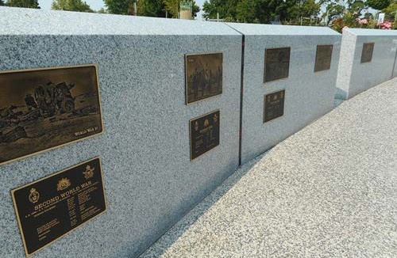

Bronze plaques installed at the Gippsland Memorial Park recognising service in wars, conflicts and peacekeeping operations. *Image supplied by Gippsland Memorial Park/Traralgon Cemetery Trust.*

## COMMEMORATION AND ANZAC DAY SERVICES

The VVC supports ANZAC Day and other commemorations and events in local communities through the provision of funding from the Victorian Veterans Fund distributed under the Victoria Remembers Minor Grant program. Organisations awarded funding for commemorative events impacted by coronavirus (COVID-19) in 2019-20 will now conduct these events in 2020-21.

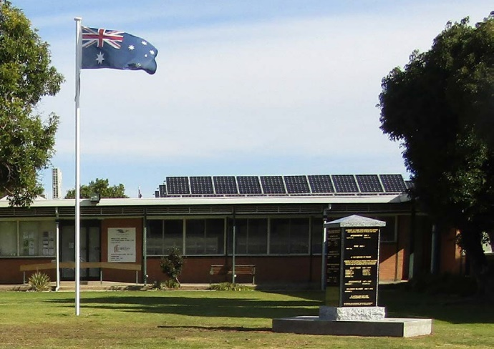

A new monument installed in the Cohuna Memorial Park to local residents who participated in Boer and Korean Wars, Malaysian and Afghanistan Campaigns and those that undertook Peacekeeping operations. *Image supplied by the Cohuna/Leitchville RSL Sub-Branch.*

## GRANT PROGRAM HIGHLIGHTS

The VVC through its grant programs is proud to support community projects which promote a better understanding of the service and sacrifice of Victoria’s veterans in war and peacekeeping operations and commemorate those who have died in the performance of service or duty. A complete list of awarded grants is available on pages 13-14.

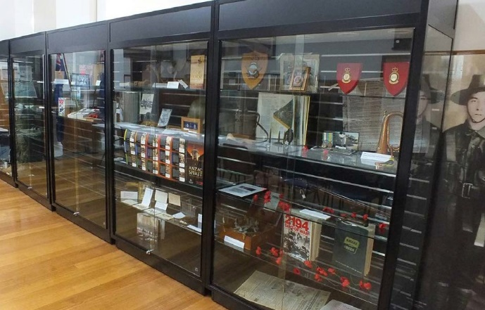

New museum quality cabinets installed at Lara RSL Sub-Branch supporting their efforts to catalogue, display and preserve their collection. *Image supplied by the Lara RSL Sub-Branch.*

# Corporate Governance

## COUNCIL MEETINGS

The *Veterans Act 2005* requires that the VVC must meet at least eight times each year. The Council held nine meetings during the period 1 July 2019 to 30 June 2020, three of which were held by tele- and video-conference due to coronavirus (COVID-19).

## COMMITTEE STRUCTURE

The VVC has established two committees to facilitate the performance of its functions under the Act.

## FUNDING SUB-COMMITTEE

The Funding Sub-Committee is responsible for the development and annual review of the guidelines for the Victorian Veterans Fund Grant Programs and the ANZAC Day Proceeds Fund, assessing applications for both funds and making funding recommendations to the VVC for grants from both funds. During 2019-20 the Funding Sub-Committee was chaired by Dr Ross Bastiaan AM RFD. The other members of the Sub-Committee were Wing Commander Sharyn Bolitho, Ms Elizabeth Brown, Lieutenant Commander Peta Irving (Rtd) and Mr Geoffrey Brewer. The Committee met on two occasions throughout the year.

## GOVERNANCE SUB-COMMITTEE

The Governance Sub-Committee is responsible for ensuring the VVC complies with all financial and legal requirements under the *Veterans Act 2005* and any other relevant legislation. The Governance Sub-Committee is also responsible for governance of the six patriotic funds for which the Council is Trustee and the development of the VVC annual report. During 2019-20 the Governance Sub-Committee was chaired by Mr Bruce Mildenhall. The other members of the Sub-Committee were Lieutenant Commander Pelagia Markogiannakis, Ms Kim McAliney, Mr Jamie Twidale CSM and Brigadier Michael Annett CSC. The Governance Sub-Committee met on three occasions during the year to oversee VVC’s administration of patriotic funds and associated investment accounts.

## SECRETARIAT SUPPORT

Secretariat support to the VVC and both Sub-Committees was provided by the Veterans Branch within the Department of Premier and Cabinet.

## AUDITED FINANCIAL RECORDS

The VVC financial results are aggregated into the Department of Premier and Cabinet’s financial statements pursuant to

a determination made by the Minister for Finance under section 53(1)(b) of the *Financial Management Act 1994*. The Department’s Financial Statements can be found at:

vic.gov.au/dpc-governance-and-reporting

On 6 September 2018, the VVC applied to the Minister for Finance seeking a full exemption from the Standing Directions of the Minister for Finance under the *Financial Management Act 1994*. On 1 October 2018, this application was approved

by the Minister for Finance, exempting on an ongoing basis the Victorian Veterans Council from compliance with all requirements of the Standing Directions.

# Anzac Day Proceeds Fund

The ANZAC Day Proceeds Fund receives contributions from sporting events held on ANZAC Day across Victoria which are collected by Sport and Recreation Victoria within the Department of Jobs, Precincts and Regions in accordance with section 4A of the *ANZAC Day Act 1958*.

Grants totalling $581,407 were approved from the ANZAC Day Proceeds Fund to 31 individual projects during the financial year ending 30 June 2020. Grant recipients are detailed in the table below.

## ANZAC DAY PROCEEDS FUND 2019-20 APPROVED GRANTS

| **Organisation** | **Project** | **Amount** |
| --- | --- | --- |
| 2/14 Battalion Association Inc. | Production and Distribution of the 2/14 Battalion Association Newsletter | $ 2,400 |
| 39th Australian Infantry Battalion (1941-43) Association Inc | 39th Battalion Association Newsletter | $ 1,500 |
| 458 RAAF Squadron Association | Enhancing Publication of 458 Squadron's Newsletter - in its 70th year | $ 2,016 |
| Air Force Association - Victoria | Newsletter Program | $ 7,140 |
| Air Force Association - Victoria | Veterans' Welfare Program | $ 18,000 |
| Australian Peacekeepers & Peacemakers Veterans' Association Victorian Branch Inc | Welfare Support | $ 5,000 |
| Australian Student Veterans Association | Veteran Education Access and Support | $ 30,000 |
| Ballarat Veterans Assistance Centre | Veterans Attendance ANZAC Day Service Shrine of Remembrance | $ 5,500 |
| Ballarat Veterans Assistance Centre | Ballarat ADF Veterans attendance Vietnam Veterans service Shrine of Remembrance | $ 2,000 |
| Carry On (Victoria) | Veteran Welfare and Support | $ 138,000 |
| Carry On (Victoria) | Welfare and IT Support | $ 10,000 |
| Colac Legacy Club Inc | Colac Legacy community bus | $ 2,500 |
| Defence Force Welfare Association | Camaraderie Magazine and Branch Supplement Production and Distribution | $ 3,420 |
| Geelong Legacy Club | Geelong Legacy Widows Utility Allowance | $ 12,000 |
| Macedon Ranges Group of Bendigo Legacy Inc. | Heating Support for Legacy Widows | $ 5,000 |
| Melbourne Legacy | Melbourne Legacy "The Answer" Newsletter for War Widows | $ 40,000 |
| Melbourne Legacy | Youth Education Essentials | $ 48,000 |
| Melbourne Legacy | Welfare Support | $ 15,000 |
| Melbourne Western Region TPI Social Club Inc | Transport Support to Planned Social Club Activities | $ 800 |
| Mornington Peninsula Legacy Club Inc. | Publications Project | $ 5,600 |
| Mornington Peninsula Legacy Club Inc. | Christmas Gathering for Legacy dependants with a disability | $ 850 |
| Returned & Services League of Australia Victorian Branch | General Appeals Patriotic Fund | $ 100,000 |
| Returned & Services League of Australia Victorian Branch | RSL Active | $ 10,000 |
| Soldier On | Soldier On Victoria Pathways Program | $ 50,000 |
| South Gippsland Group of Melbourne Legacy | Winter Fuel | $ 14,800 |
| South Gippsland Group of Melbourne Legacy | Transport | $ 4,381 |
| The Australian Federation of Totally & Permanently Incapacitated (TPI) Ex Servicemen & Women (Victorian Branch) | TPI Phone and Mailout Support | $ 8,000 |
| The Legacy Club of Ballarat Inc | 2020 Winter Heating Allowance | $ 16,500 |
| The Legacy Club of Bendigo Inc | Utility (Heating) assistance for Beneficiaries of Bendigo Legacy | $ 6,000 |
| Torquay RSL Sub-Branch | Member Welfare | $ 12,000 |
| Vietnam Veterans Federation Vic Branch Inc | Welfare Support | $ 5,000 |
|  | **TOTAL ANZAC Day Proceeds Fund** | **$ 581,407** |

# Victorian Veterans Fund

The Victorian Veterans Fund was established under the *Veterans Act 2005*. Revenue for the Veterans Fund comes from the Community Support Fund (CSF) and is equal to one day’s revenue of the CSF.

Grants totalling $379,706 were approved for 36 projects through the Victorian Veterans Fund, distributed under the Victoria Remembers Minor Grant Program during the financial year ending 30 June 2020. Grant recipients are detailed in the table below.

## VICTORIAN VETERANS FUND 2019-20 GRANT RECIPIENTS (VICTORIA REMEMBERS MINOR GRANT PROGRAM)

| **Organisation** | **Project** | **Amount** |
| --- | --- | --- |
| Ararat Legacy Inc | Project Remembrance 2020 | $ 2,500 |
| Australian National Veterans Arts Museum | March to Art: Place Exhibition | $ 8,000 |
| Banyule City Council | Homefront Sculptures Education Resources | $ 8,200 |
| Bass Valley Friends of the RSL | Remembering the Boer War | $ 675 |
| Battle of Australia Foundation in Victoria | Battle for Australia Ceremony | $ 10,000 |
| Borough of Queenscliffe | ANZAC Commemoration Project | $ 7,000 |
| Briagolong RSL Sub-Branch | ANZAC Park Memorial Wall Briagolong | $ 2,600 |
| Brimbank City Council | Sassella Park Servicemen and Servicewomen Monument | $ 15,000 |
| Buchan South Avenue of Honour | Buchan South Avenue of Honour War Memorial | $ 28,344 |
| Charlton RSL Sub Branch | RSL WWII Remembrance Mural | $ 10,000 |
| City of Ballarat | Ballarat ANZAC Day Commemorative Services | $ 9,000 |
| Cohuna/Leitchville RSL Sub-Branch | Boer Korean & other conflicts War Monument | $ 13,127 |
| Darwin Defenders 1942-45 Melbourne Branch | Commemoration of the Bombing of Darwin | $ 4,032 |
| Federation University Australia | The Lucas Girls and World War One Soldiers | $ 10,500 |
| Jamieson Community Group & Assoc. Bodies Inc. | Matthews Reserve Avenue of Honour - Brass Plaques | $ 23,238 |
| Lara RSL | Museum from the Veterans to the Community | $ 7,522 |
| Lemnos Gallipoli Commemorative Committee Inc | Annual Commemorative Service equipment | $ 2,500 |
| Maldon RSL Sub-Branch | Preservation and Presentation of Memorabilia | $ 1,972 |
| Melbourne Legacy | 2020 Legacy ANZAC Commemoration Student Ceremony | $ 18,000 |
| Military History and Heritage Inc | Production of a history of 'Guinea Gold' | $ 4,000 |
| Mt Macedon Memorial Cross Council for Commemorative Services Inc | 2020 Mt Macedon ANZAC Dawn Service | $ 9,000 |
| National Trust of Australia (Victoria) | Remembering Napier Waller: An exhibition of wartime | $ 15,000 |
| National Vietnam Veterans Museum Ltd | Honouring their service through display of uniform | $ 7,746 |
| Rotary Club of Templestowe | Manningham Schools ANZAC Service | $ 3,800 |
| Royal United Services Institute of Victoria Incorporated | Additional Map and Book Storage | $ 5,797 |
| Sale RSL & Community Sub-Branch | Remembering World War Two | $ 2,000 |
| Shrine of Remembrance | 'Love and War' Shrine exhibition | $ 27,000 |
| Sir Edward Weary Dunlop Medical Research Foundation | Sir Edward 'Weary' Dunlop Commemorative Service | $ 4,000 |
| Soldiers Memorial Institute Military Museum | Anzac Spirits | $ 21,758 |
| Tatura RSL Sub-Branch | Tower Mural | $ 27,787 |
| Torquay RSL Sub-Branch | ANZAC Day Dawn Service 2020 | $ 14,000 |
| Traralgon Cemetery Trust | War Memorial Precinct | $ 7,808 |
| Traralgon RSL Sub-Branch Inc. | Giant Screen ANZAC Day | $ 5,000 |
| Vasey RSL Care | Frankston South Wall of Remembrance | $ 19,000 |
| Walwa Services Memorial Hall | Storing Our Memories | $ 18,800 |
| Wonthaggi RSL Sub-Branch | Bass Virtual Honour Board web page | $ 5,000 |
|  | **TOTAL Victorian Veterans Fund** | **$ 379,706** |

# Patriotic Funds

## PATRIOTIC FUNDS

The VVC, in partnership with Consumer Affairs Victoria, the regulator of patriotic funds, provides advice to ex- service organisations on how patriotic funds can be raised and appropriately used, including transfer and winding up arrangements.

The VVC is now the trustee for six patriotic funds which are administered in accordance with Part 4 of the *Veterans Act 2005.*

## THE AUSTRALIAN LEGION OF EX-SERVICEMEN AND WOMEN SCHOLARSHIP FUND – ALBERT COATES MEMORIAL TRUST

The Australian Legion of Ex-Servicemen and Women Scholarship Fund, in association with the Albert Coates Memorial Trust provides funding for scholarships awarded to students who are studying courses for the training of paramedics, nurses and doctors in emergency care at Victorian universities.

In 2019-20, the VVC approved the disbursement of $21,000 to the Albert Coates Memorial Trust to allocate scholarships for Rural Emergency Nursing studies. In 2019-20 recipients included Francis Ratnakumar, Mark McOwen, Dr. Wen-Shen Lee, Bambi Reichman and Elise Wright.

## THE AUSTRALIAN LEGION OF EX-SERVICEMEN AND WOMEN SCHOLARSHIP FUND NO 1 – NURSES MEMORIAL CENTRE

The Fund, first established in August 2006, provides support for scholarship grants awarded on an annual basis to students that are undertaking postgraduate studies in care of the older person or Palliative Care at a recognised university. The Funds, administered by the VVC, are provided to the Australian Nurses Memorial Centre (ANMC) as the facilitator of the scholarships. In 2019-20, the VVC approved the disbursement of $30,000 to the ANMC for these scholarships.

On 5 March 2020 Roger Clifton represented the VVC at the ANMC Scholarship Awards. The Australian Legion of Ex- Servicemen and Women Scholarships were awarded to Rebecca Jedwab, Cindy Joseph, Alison Lemoh, Kylie Moon, Anne Craigie.

## THE WAR WIDOWS AND WIDOWED MOTHERS ASSOCIATION SCHOLARSHIP FUND

The Fund supports scholarships awarded by the Federation University Australia to students undertaking graduate or postgraduate study in the fields of nursing, palliative care, aged care or midwifery.

## THE VICTORIAN BLINDED SOLDIERS’ WELFARE PATRIOTIC FUND

Established in April 2013 from funds provided by the Blinded Soldiers’ Association and a letter bequest from the Estate of the Late Lucy Adamson, this Fund provides welfare assistance to visually impaired veterans and their dependants and offers assistance for former Australian

Defence Force members who have visual impairment due to their service in defence of our nation.

## THE EXTREMELY DISABLED ASSOCIATION (EDA) PATRIOTIC FUND

This Fund supported the now discontinued Victorian Veteran Community Story Writing and Art Competition (SWAC), which was facilitated by Austin Health’s Heidelberg Repatriation Hospital. In acknowledgement of the EDA’s longstanding support of the SWAC, the VVC provided $10,000 from the Fund to Austin Health to purchase SWAC artwork for permanent display at the Heidelberg Repatriation Hospital.

## AUSTRALIAN UNITED EX-SERVICES ASSOCIATION PATRIOTIC FUND

This Fund was established in 2015 for the purpose of providing funding for post-graduate study in the field of veterans’ health. A Memorandum of Understanding with Austin Health was signed in February 2016 to deliver the scholarships for training post-graduate students in Cognitive Processing Therapy with an associated year of supervision.

AUTHORISED AND PUBLISHED BY   
THE VICTORIAN GOVERNMENT

Victorian Veterans Council

C/- Department of Premier and Cabinet, Veterans Branch,   
1 Treasury Place, Melbourne, Victoria, 3002

ACCESSIBILITY

If you would like to receive this publication in   
an alternative format, please telephone   
the Veterans Branch,   
Department of Premier and Cabinet on   
(03) 7005 1308.

This document is also available on the internet at  
[veterans.vic.gov.au](https://veterans.vic.gov.au)

